8th Grade Social Studies
Standard | Items
(4) History. The student understands significant political and economic issues of the revolutionary era. The student is expected to:  (C) explain the issues surrounding important events of the American Revolution, including declaring independence; writing the Articles of Confederation; fighting the battles of Lexington, Concord, Saratoga, and Yorktown; enduring the winter at Valley Forge; and signing the Treaty of Paris of 1783; | 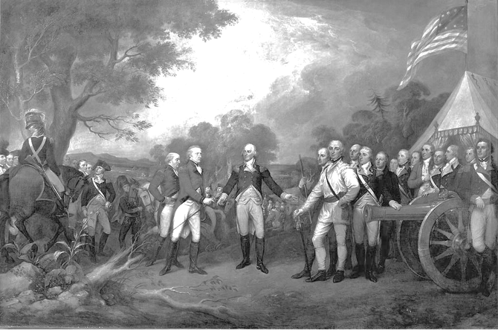  Burgoyne felt he had no option but to press on to Albany. The American army, however, was blocking his way at Bemis Heights. The British made two attempts to break through American defenses, but failed. After the second attempt, they withdrew (,and) they were surrounded by American troops. The British had no choice but to surrender which they did on October 13, 1777. One quarter of the British forces in North America thus surrendered.  1. The event described and illustrated above is considered a turning point of the Revolutionary War because  A the success of the Americans demonstrated they could succeed without foreign aid or support.  B the American defeat signaled the need to change military strategy.  C the American victory persuaded the French to offer their assistance.  D it marked the end of General Cornwallis’ occupation of the South.
 | 2.0 Items

8th Grade Social Studies
Standard | Items
(5) History. The student understands the effects of reform and third-party movements in the early 20th century. The student is expected to:  (B) evaluate the impact of muckrakers and reform leaders such as Upton Sinclair, Susan B. Anthony, Ida B. Wells, and W. E. B. DuBois on American society | And shortly afterward . . . a physician, made the discovery that the carcasses of steers which had been condemned as tubercular by the government inspectors . . . were left upon an open platform and carted away to be sold in the city. . . .  —Upton Sinclair, The Jungle, 1906  20 Public response to revelations such as the one in this excerpt led to the establishment of regulations that were eventually enforced by the —  F Food and Drug Administration  G Centers for Disease Control  H Department of Commerce  J Institution of Education Sciences
 | 2.0 Items

